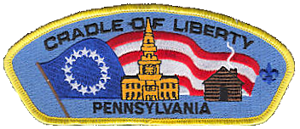

**PACK 290**

**CUB SCOUT PARENTS’ ORIENTATION GUIDE**

**WELCOME TO THE ADVENTURE OF**

**CUB SCOUTING!**

Where character counts and

the adventure begins…

**Greetings and Welcome to Cub Scout Pack 290!**

If you are new to Cub Scouting, you will have many questions at first! We all did! Being “new” at anything always takes a little time. We like to think of our Pack as a big family. After you have been with us for a little while, you will start to feel right at home!

As a new family to either Cub Scouting or to our Pack, you will have many questions. The contents of this handbook will try and help answer some of those questions. Some of the things that you will find in this handbook are:

✪ 2012 and 2013 calendars for our Cub Scout Pack’s activities and events,

✪ Pack rules and regulations, the Pledge of Allegiance, the Cub Scout Promise, the Law of the Pack, and the Cub Scout Motto,

✪ An overview of a Cub Scout Pack and position descriptions for adult leaders,

✪ Obligations for all of us, finances, awards, Pack organization, and some web sites.

Some upcoming dates to make note of are…

✪ September Parents meeting - Thursday, September 20, 2012 at 7:00 PM

✪ September Pack meeting - Thursday, September 27, 2012 at 7:00 PM

✪ October Pack meeting – Thursday, October 26th, 2012 at 7:00 PM

If you have any questions, concerns, or comments, please do not hesitate to contact me.

Best Regards,

David Montvydas

Cubmaster

Cub Scout Pack 290

215-742-3395 dmontvydas@verizon.net

**Cub Scout Pack 290 Rules and Regulations**

* Common courtesy and respect will be shown to each other at all times and is expected by the Scouts, parents, Leaders and guests.
* Parents are responsible for the behavior of their children and guests at all Scouting functions.
* Pack meetings will start on time and should last less than 90 minutes. Pack meetings should be controlled by the Cubmaster and Asst. Cubmaster. The Pack meetings should follow a pre-determined agenda set by the Cubmaster, Asst. Cubmaster, and Pack Committee.
* Den meetings will be controlled by the respective Den Leaders and Assistants. Two deep leadership will be in effect at all times.
* After a Den meeting or Pack meeting (or any Scouting event), the meeting area should be neat and clean regardless of the condition before the meeting. BSA policy dictates leaving an area cleaner than when it was found. **Everyone** in attendance **must** help with the necessary clean up.
* Any and all trips or meetings held off the premise of St. Cecilia’s property require the prior approval of the Pack Committee. This is an insurance issue required to protect the Chartered Organization. **There is no smoking allowed in transit.**
* Any event awarding patches, pins, etc…, requires the participation and attendance of the Scout to receive them. There are no exceptions.
* Uniforms must be kept clean and neat. The uniform consists of a shirt, allowable insignia correctly placed, belt, and neckerchief with slide. Uniform pants are not required. Any dark green or blue pants (such as school uniform pants) or jeans without holes are acceptable. Sweat pants and camos are not encouraged. Uniform requirements at Den meetings are at the discretion of the Den Leader(s). The full uniform is required for all Pack meetings and special events.
* There is no alcohol allowed at any Cub Scout event or function.
* Smoking or tobacco products are prohibited in front of the Scouts at all Cub Scout functions. The use of tobacco products must only be used in designated smoking areas away from and out of sight from the Scouts.
* Boys are not allowed to bring outside distractions to den or pack functions (ex. Electronic games, toys, etc.).

**Cub Scout Pack 290 Goals**

Some of the goals of Cub Scout Pack 290 are:

* Influence each Scout’s character development.
* Develop habits and attitudes of good citizenship.
* Encourage good sportsmanship and pride in growing strong in mind and body.
* Improve understanding and communication within the family.
* Strengthen skills in getting along with and respecting others.
* Foster a sense of personal achievement by developing new interests and skills.
* Provide fun and exciting things to do.
* Encourage each Scout to, “**Do Your Best**”.
* Prepare each Cub Scout to become a Boy Scout.

And most importantly,

* To have fun!

# The 10 Purposes of Cub Scouting

1. Character Development

2. Spiritual Growth

3. Good Citizenship

4. Sportsmanship and Fitness

5. Family Understanding

6. Respectful Relationships

7. Personal Achievement

8. Friendly Service

9. Fun and Adventure

10. Preparation for Boy Scouts

# Cub Scouting’s 12 Core Values

1. Citizenship

2. Compassion

3. Cooperation

4. Courage

5. Faith

6. Health and fitness

7. Honesty

8. Perseverance

9. Positive attitude

10. Resourcefulness

11. Respect

12. Responsibility

# Cub Scout Promise

I, promise

To DO MY BEST

To do my DUTY to GOD

And my Country

To HELP other people, and

To OBEY the LAW of the Pack



# 

# Tiger Cub Motto

Search Discover Share

# Cub Scout Motto

DO YOUR BEST

# Law of the Pack

The Cub Scout follows Akela.

The Cub Scout helps the pack go.

The pack helps the Cub Scout grow.

The Cub Scout gives goodwill.

# Parent’s Promise

As a parent of a Cub Scout,

I will do my best

To help my son

Live up to the Cub Scout Promise

And obey the Law of the Pack.

I will work with my boy

On his achievements and projects.

I will attend the pack meetings

And help as needed

To make the pack go.

# Colors

The Cub Scouting colors are Blue and Gold. They have special meanings, which will help boys see beyond the fun of Cub Scouting to its ultimate goals.

* The blue stands for truth and spirituality, steadfast loyalty, and the sky above.
* The gold stands for warm sunlight, good cheer, and happiness

**YOUR SON, SCOUTING AND YOU**

**SCOUTING… AN AID TO PARENTS**

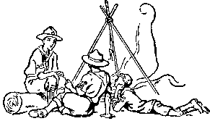As a parent, you want your son to grow up to be a self-reliant, dependable, and caring individual. Scouting has these same goals in mind for him. Since 1910, we have been weaving lifetime values into fun and educational activities designed to assist parents in strengthening character, good citizenship and physical fitness in youth.

Scouting teaches family values. We know that boys do not join Scouting just to get their character built. Boys join because it is fun.

**SCOUTING IS FUN WITH A PURPOSE!**

**TIGER CUB PROGRAM**

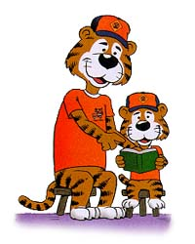

* **First Grade**
* Each boy/adult team is a member of a Tiger Cub den that has three to eight boy/adult partner teams.
* Meets at least two times each month in a den meeting
* Has one outing a month, called a Go See It.
* Attends the Pack meetings
* Each Pack has a Tiger Cub Den Leader that plans and carries out a year-round program of activities for the Tiger Cub Den. Each month, the den leader works with different boy/adult partner team to plan the monthly den meetings, the Go See It, and the den’s part in the pack meeting. This is called shared leadership.

**CUB SCOUT PROGRAM**

* **Second through Fifth Grade**
* Your boy is a member of a den that has four to eight boys
* Meets once a week, regularly scheduled at the leader’s convenience
* Is led by a den leader (usually a parent).
* Has an assistant den leader, and often a den chief (an older Boy Scout), and a denner (a Cub Scout elected by den members) to assist the den leader.
* Has games, crafts, stunts, songs and ceremonies at meetings, and periodic field trips.

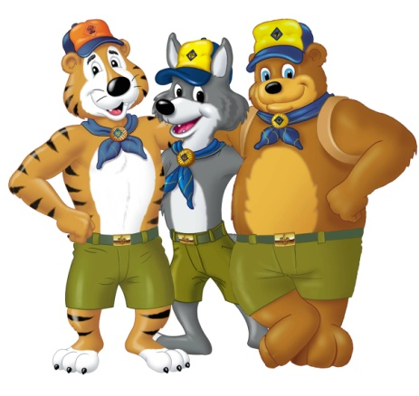**THE CUB SCOUT PACK**

**First through Fifth Grade**

Your boy is a member of a Pack that:

* is made up of one or more dens.
* Meets once a month – all Tiger Cub and Cub Scout families are expected to participate.
* Has meetings led by the Cubmaster.
* Is the climax of the month’s den meetings and activities.
* Has games, skits, stunts, songs and ceremonies at meetings, and presentation of badges that boys earned that month.

Our Pack is run by the Pack Committee, which:

* Is made up of den leaders, pack leaders, the pack trainer, **and all parents.**
* Meets once a month or more often if needed.
* Is led by a Committee Chairman.
* Selects leadership, finds meeting places, performs recordkeeping, manages pack finances, orders badges, maintains pack equipment, helps train leaders, and recognizes leaders.

Our Pack is owned by a Chartered Organization, which:

* Includes schools, parent-school organizations, religious organizations, service clubs, and other organizations interested in youth.
* Approves leadership, helps secure a meeting place, keeps Pack within sponsor’s and Boy Scout guidelines and policies.
* Selects a Chartered Organization Representative (a liaison between our Pack and our sponsor).





**TIGER CUB PROGRAM INFORMATION**

Tiger Cubs, BSA, is a one-year program for first-grade boys. Each boy participates with a parent (or another adult family member) in family-oriented activities. These include activities from family camping to preparing for emergencies.

The time you and your son spend in Tiger Cubs is meant to be fun, a chance to get to know one another better, and an opportunity to do things with your family as well as other members of the Tiger Cub group whom you see at weekly meetings.

**CUB SCOUT PROGRAM INFORMATION**

Cub Scouting teaches your son to “do his best” and be helpful of others as expressed in the Cub Scout Promise.

Cub Scouting is a home and neighborhood-centered program designed to support family life for boys in second through fifth grades. Each Cub Scout learns to respect his home, country, God and other people. The program also helps boys this age to:

* 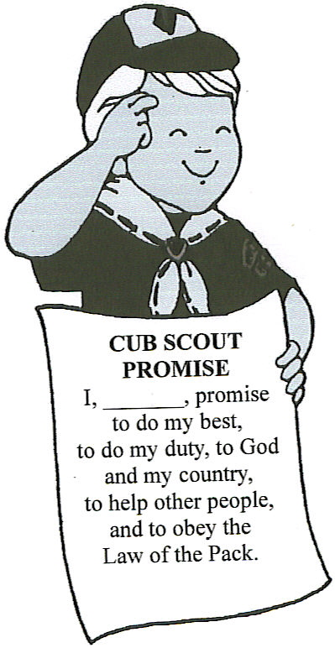Learn new physical skills through sports, crafts and games.
* Learn how to get along with others through group activities.
* Develop new mental skills such as writing and calculating.
* Develop personal independence.

A Cub Scout den provides your son with a group of boys his own age in which he can earn status and recognition. In the den, he will also gain a sense of personal achievement for the new skills he learns.

In a society where your son is often taught that winning is everything, Cub Scouting teaches him to focus on doing his best and being helpful to others as expressed in the Cub Scout Motto and Promise.

**THE ADVANCEMENT PLAN**

Some advancement requirements are done at den meetings but most are done at home with the family. The responsibility of a boy’s advancement in Cub Scouting lies with the family and not with the Pack.

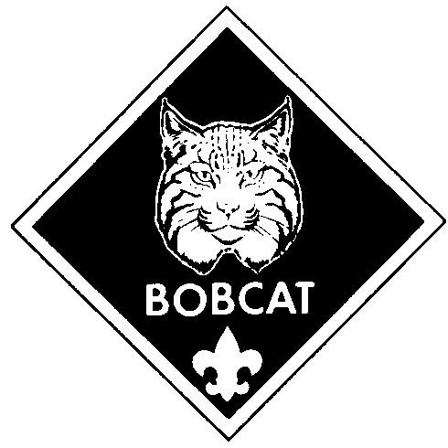

**BOBCAT**

A boy’s first step after registering as a Cub Scout, regardless of his age, is to pass the Bobcat Requirements. They are: learning the Cub Scout Promise, Law of the Pack, handshake, salute, sign, motto and meaning of “Webelos.” After receiving the Bobcat badge, each boy works on requirements based on his grade level.

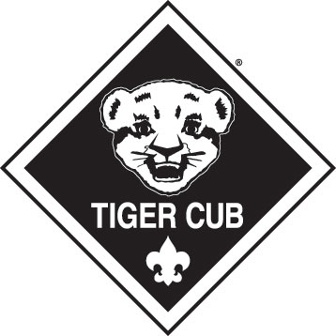**TIGER CUBS**

The Tiger Cub program is for first-grade (or age 7) boys and their adult partners. There are five Tiger Cub achievement areas. The Tiger Cub, working with his adult partner, completes 15 requirements within these areas to earn the Tiger Cub badge. These requirements consist of an exciting series of indoor and outdoor activities just right for a boy in the first grade. Each achievement has three parts: a family activity, a den activity, and a Go See It outing. A boy receives totem beads as he completes each part:

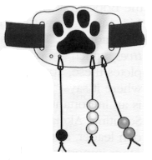

* A *white bead* for each required family activity part he completes
* An *orange bead* for each required den activity part he completes
* A *black bead* for each required Go See It part he completes

**WOLF**

The Wolf program is for boys who have completed first grade (or are age 8). To earn the Wolf badge, a boy must pass 12 achievements involving simple physical and mental skills. The parent signs each completed achievement. Achievements completed at the den meetings will be signed by the Den Leader. For every 3 achievements, the scout receives a yellow Immediate Recognition Bead. When he has all 4 beads, he is eligible for his Wolf badge. He may choose to earn Gold and Silver Arrow Points by completing 10 electives for each arrow. See the Wolf book for a more detailed explanation of the requirements.



**ARROW POINTS**

For every 10 electives a boy completes, he earns an Arrow Point. A boy may earn as many Arrow Points as he is able.

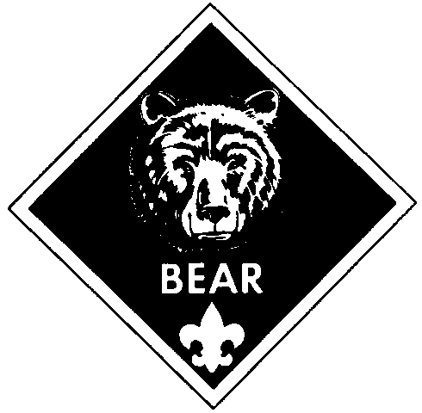**BEAR**

The Bear rank is for boys who have completed second grade (or are age 9). There are 24 Bear achievements in four categories. The Cub Scout must complete 12 of these to earn the Bear badge. These requirements are somewhat more difficult and challenging than those for Wolf rank. The parent signs each completed achievement. Achievements completed at the den meetings will be signed by the Den Leader. For every 3 achievements, the scout receives a red Immediate Recognition Bead. When he has all 4 beads, he is eligible for his Bear badge. He may choose to earn Gold and Silver Arrow Points by completing 10 electives for each arrow. See the Bear book for a more detailed explanation of the requirements.

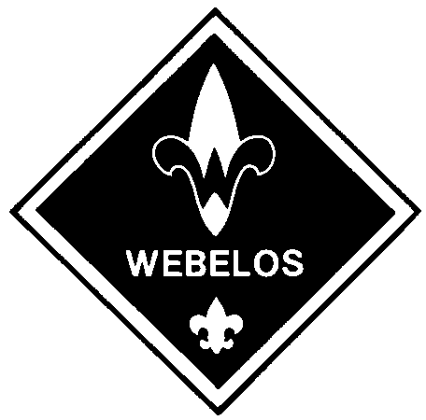**WEBELOS/Arrow of Light**

The final rank in Cub Scout is open to 4th and 5th grade boys (or those aged 10). This is an 18 month program. These dens are led by an adult Webelos leader. The boys work on requirements for the Webelos badge, 20 activity badges and the Arrow of Light Award (the highest award in Cub Scouting. Refer to the Webelos book for additional details.

Camping and other outdoor programs are an important part of the 18-month Webelos program. In February of a Webelos’ fifth-grade year, he graduates from Cub Scouting into the adventure of Boy Scouting at an impressive graduation ceremony. The purpose of the Webelos program is to prepare a Scout for his Boy Scouting experience. A well run Webelos den will ease the transition and allow scouts to advance more quickly to the Tenderfoot rank in Boy Scouts. Every boy deserves an opportunity to be a Boy Scout.

**SPECIAL ACTIVITIES & PROGRAMS**



**PINEWOOD DERBY**

Parent/son project that builds a racecar made from a block of wood. Car must weigh 5 ounces or less and must clear the track. Be there the day of the big race!



**SCOUTING FOR FOOD**

Food drive held to benefit local food-banks. Part of our program to help the hungry.

**DAY CAMP**

Exciting summertime activity that includes crafts, games, nature, sports, songs and skits. Day Camp runs five days.

**OTHER ACTIVITIES**

Phillies Game, Klondike Derby, Religious Medals, Halloween Party, Scouting for Food, Christmas Caroling, Christmas Party, Scout Sunday, Blue & Gold Banquet, Museum Camp-In, Pinewood Derby, Environmental Day, Annual Family Camping and Other………………….



**BOYS’ LIFE MAGAZINE**

A magazine for boys and adults. *Boys’ Life* has interesting features on Scouting, sports, hobbies, magic, science and U.S. history. There are also jokes, comics, and short stories. Subscription is $12.00 per year for 12 issues.

**BLUE AND GOLD BANQUET**

Our birthday party for Cub Scouting usually held in February. This is the time where Arrow of Light Scouts advance to become Boy Scouts as well.

**CAMPING**

As a Pack we have one (sometimes more) camping opportunity each year. Pack 290 has an annual camping outing at French Creek State Park and sometimes has opportunities to camp along with the Cradle of Liberty Council at approved in-council sites. Cub Scout Resident Camp in the summer is a great event for Cub Scouts to meet boys from other units and earn several achievements. The Arrow of Light Scouts have the opportunity to camp with Troop 290 in the Fall each year. This trip focuses on scout skills necessary to earn their Outdoorsman Activity Pin needed for their Arrow of Light Badge.

**HOW CAN YOU HELP?**

Scouting operates through volunteer leadership. Volunteer leaders are an example of Scouting’s principle of service to others. Naturally, parents are the primary source of leaders in the Scouting program. You volunteer not only to serve Scouting, but also to help your son and his friends, and to have the chance to be a positive influence on the youth in your community.

**WHAT DO YOU RECEIVE IN RETURN?**

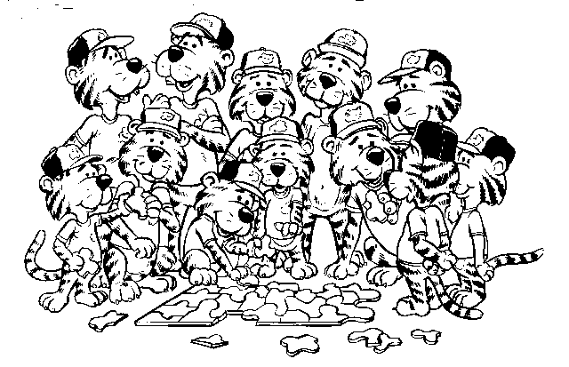Being a leader is fun, challenging and rewarding. Leaders find that their experiences help them to become better parents. The following are some of the many dividends that will enrich your life as you dedicate your time, talent and enthusiasm to Scouting:

* Fun and fellowship with other families, sharing your pride in the boys’ accomplishments.
* The privilege of helping to enrich and strengthen families.
* A chance to help boys learn good citizenship and to help shape them into men who have strength of character and are sensitive to the needs of others.
* The opportunity to help make a difference in the lives of boys as they grow strong in mind and body.
* A code to live by that will set a worthwhile example for both boys and adults.
* The satisfaction of being a member of a worldwide movement, and pride in being publicly identified as part of this organization. Wearing the Scouting uniform is a visible means of showing you believe in and stand up for the ideals and objectives of the Boy Scouts of America.
* *“You never stand taller than when you stoop to help a child.”*

**FAMILY INVOLVEMENT**

**Role of Parents**

Cub Scouting encourages closeness of family. The program will give you opportunities to take part in activities with your son that you normally might not do. It provides a positive way for parent and son to grow closer together, and encourages you to spend quality time together. There is even an opportunity for families to earn a Scouting award together (the BSA family award). In this way, Cub Scouting is a program for the entire family, and your involvement is vital to the program's success. Some specific things you can do to help your son in Cub Scouting are:

* Work with your son on projects
* Help your Cub Scout along the advancement trail
* Participate in monthly Pack meetings
* **Be an active participant in the Pack committee**
* Go on family campouts with your son
* **Provide support for your son's den and Pack**

**Work With Your Son On Projects**

Boys often begin projects at den meetings and finish them at home with the help of a parent. Such projects become the catalyst for parents and boys - frequently joined by siblings and friends - to interact with each other in a relaxed way. Because the purpose of a project is to teach a boy new skills, a project will challenge a boy to do tasks that he hasn't already mastered. It's not uncommon, therefore, for a boy to need help from his family to complete some of his projects. In Cub Scouting, boys are not expected to do things entirely on their own. So long as a boy does his best to do as much as he's capable of, it's perfectly acceptable for a parent or sibling to help him.

**Help Your Cub Scout Along The Advancement Trail**

The advancement plan is designed for parents to use to create a learning environment in their home. With the Cub Scout handbooks as a resource, parents and boys work together to complete the achievements required for each badge. The advancement plan provides fun for the boys, gives them a sense of personal achievement as they earn badges, and strengthens family understanding as adult family members work with boys on advancement projects.

While Cub Scouts learn skills and begin projects in their den meetings, the parent remains at the center of the advancement program. As each task is done or each skill is demonstrated, the parent signs the Cub Scout's handbook to record its completion. It is also important for the scout to take his handbook to den meetings to allow the Den Leader to see the parent’s sign-off on the achievements. And when the boy has completed all of the requirements to earn an award, the completion is acknowledged before the entire pack of scouts at the next pack meeting.

**Participate In Monthly Pack Meetings**

The den meetings are for Cub Scouts and their Adult Leader. The Pack Meeting is for the entire family of every Cub Scout. At Pack Meetings, parents see their sons in action with their friends, meet other parents, and join with neighbors in caring and sharing. These opportunities are scarce, and Pack Meetings highlight how Cub Scouting teaches boys cooperation and collaboration. The Pack Meeting is also a monthly showcase for all that the boys have worked on in their den meetings. Craft projects are on display, skills are demonstrated, and skits are performed to show the boys' command of the monthly theme. While boys at this age seem to be struggling toward independence, having the approval of their parents and other adults whom they admire remains important to them - so your presence at these meetings is critical to underscore the importance of the lessons your son has learned.

**Be An Active Participant In The Pack Committee**

Boy Scouts is a scout-led program; Cub Scouts is a **parent**-led program. As the parent of a Cub Scout, you have a responsibility to be an active member of the Cub Scout Pack. Attending the monthly Pack Leaders & Parents Committee Meeting is an excellent way to help guide the entire Pack and impact your son's scouting experience.

**Role of Siblings**

We know that it may be difficult for parents to attend meetings without siblings "in tow." Remembering that the meeting is to help the boy learn and grow, we welcome siblings. Please do not expect leaders to baby-sit siblings. Den Leaders plan crafts and activities to suit the Den members present. Please bring things for your other child(ren) to enjoy and we will do our best to include them in our activities where appropriate.

**PACK VOLUNTEER LEADERSHIP**

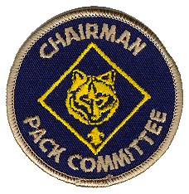Adult volunteers are the essential ingredients in running a quality Cub Scout Program. Each parent is expected to volunteer in some capacity in at least one activity. There are many, many needs – volunteer activities range from planning a specific activity at the Den meeting to coordinating a Pack activity to Pack leadership through a Committee position.

**COMMITTEE CHAIRMAN**

Presides at all Pack Committee Meetings. Helps recruit adult leaders. Also attends Pack Meetings.

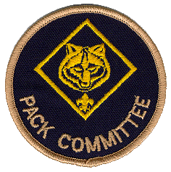

**PACK COMMITTEE**

Pack Committee (positions listed below) members perform administrative functions of the Pack.

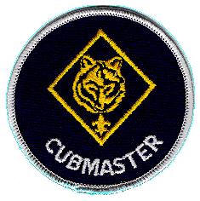

**CUB MASTER**

Helps plan and carry out the pack program with the help of the Pack Committee. Emcees monthly pack meeting and attends the Pack leaders’ meeting.

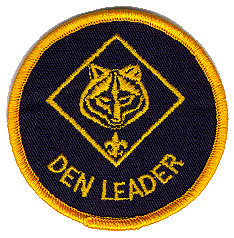

**DEN LEADERS**

Leads the den at weekly den and monthly Pack Meetings. Attends the monthly pack leaders’ meeting.

**PARENT HELPERS**

Function chairman positions to perform “one-shot” program jobs, such as coordinating pack participation in sales events, Scouting for Food, pinewood derby, blue and gold banquet, day camp, etc. These jobs are of short duration.

* Fundraising Committee
* Blue & Gold Banquet Committee
* Pinewood Derby Race Committee
* Family Campout Committee
* Event Coordinator
* Den Meeting Captain
* Pack Meeting Captain
* Event Job Volunteer

**YOU ARE NOT ALONE!**



* The staff at the Cradle of Liberty Council Scout Service Center can help or get you in touch with someone who can.

Cradle of Liberty Council 215-988-9811

Council website www.COLBSA.org

* Roundtable, a monthly leaders’ meeting for all adult volunteers in your district, is available. You can get help with crafts, games, skits, and songs for use at den and pack meetings. It’s a great place to ask questions and share ideas. The Theodore Roosevelt District Roundtable meets the 2nd Wednesday of every month at 7:30pm, at Philadelphia Protestant Home located on Martin’s Mill Road.

There is material for Den and Pack planning provided.

* Most Packs have a Pack library that contains the leader books you need.
* Your district has a team of volunteers called the District Committee that develops quality district-wide programs in which boys can participate.
* Our Pack has a district provided Unit Commissioner. They are at our service to check on the health of the Pack and are a communications link between our pack and the Cradle of Liberty Council.
* All new leaders must get basic training immediately online at [www.scouting.org](http://www.scouting.org). Click on Youth Protection Training, Cub Scout Fast Start Training, Leader Specific and This is Scouting. The Youth Protection Training certificate must be submitted with all new adult applications.
* University of Scouting offers a multitude of training classes. It is held one Saturday per year at a location to be determined by Council.

## Uniforms and Books

The uniform consists of a shirt, allowable insignia correctly placed, belt, and neckerchief with slide. Uniform pants are not required. Any dark green or blue pants (such as school uniform pants) or jeans without holes are acceptable. Sweat pants and camos are not encouraged. Uniform requirements at Den meetings are at the discretion of the Den Leader(s). The full uniform is required for all Pack meetings and special events.



### Standard Field Uniform

The standard Pack 290 Field uniform consists of the following components:

* Official BSA short-sleeved shirt with appropriate insignia   
  (long-sleeved shirt optional but NOT recommended)  
  Shirts should be neat, clean and tucked in
* Neckerchief (bolo tie is optional for adult leaders)
* Any neckerchief slide
* Any shoes or sneakers; no sandals or shoes with wheels
* Cub Scout Hat (optional)
* Any BSA belt and any BSA buckle (optional)
* Pants or shorts must be clean and not ripped or torn
* A red “brag vest” may be worn to display awards and patches *(optional)*

### Casual Activity Uniform

The Activity uniform for our Pack consists of the following components:

* Pack 290 T-Shirt or other BSA related T-Shirt
* Any shoes or sneakers, sandals OK when appropriate, no shoes with wheels
* Any BSA belt and any BSA buckle (optional)
* Hat (optional)
* Pants or shorts must be clean and not ripped or torn

### New Webelos/AOL Uniform

* + Official Tan *Boy* Scout Shirt (buy it big, he'll be wearing it into Boy Scouts)
  + ANY olive pants or jean shorts
  + Webelos (plaid) neckerchief and slide
  + Webelos (plaid) cap (optional)
  + Cub Scout Belt (optional)
  + Blue shoulder loops
  + Webelos “colors”
  + Cradle of Liberty Council Shoulder Patch
  + World Crest
  + Pack numerals 290 (Green)
  + Webelos Handbook

**INSIGNIA PLACEMENT**

Cub Scout and Webelos Scout Insignia



**Right Sleeve**. Wear U.S. flag, den numeral, and Quality Unit Award (if earned) as shown. Webelos Scouts may wear den emblem instead of den numeral. Only the most recently earned Quality Unit Award may be worn. Wear the Webelos colors immediately below and touching the U.S. flag if no den numeral is worn. If den numeral is worn, wear colors below and touching numeral. Wear activity badges on the colors.

**Left Sleeve**. Wear council patch and pack numeral as shown. The veteran unit insignia bar (25, 50, 55, or 60 years) is worn centered below the council patch and above the numeral, and touches both. Denner cord or assistant denner cord is worn over left shoulder.



**Left Pocket**. Cub Scouts wear badges of rank as shown: Tiger Cub, Bobcat, Wolf, and Bear. Gold Arrow Points are worn beneath the pocket and below the badge for which they were earned. Silver Arrow Points are worn below the Gold Arrow Points in double rows. Webelos Scouts wear only current badge of rank (Bobcat,

Wolf, Bear, or Webelos badge) centered on pocket. Arrow of Light Award is worn centered below pocket. Wear medals just above pocket seam, and service stars centered just above medals or knots, or 3⁄8 inch above seam if no medals are worn. Gold background disks are worn with service stars for Cub Scouting service, including Tiger Cub service. Not more than five medals may be worn. Wearing sequence for medals or knots is at the wearer’s discretion. The only knots worn by Cub Scouts are the religious emblem knot and a lifesaving or meritorious award knot. The World Crest is worn centered between the left shoulder seam and the top of the left pocket.



**Right Pocket**. Temporary insignia are not necessary in uniform inspection, but if worn, must be centered on the pocket. Progress Toward Ranks (with thong and beads) for Cub Scouts or Compass Points emblem for Webelos Scouts is fastened to button under flap of right pocket with flap buttoned. The National Summertime Award is pinned centered on the right pocket flap.

**Olive/Tan Webelos Scout Uniform**. Webelos Scouts electing this option wear blue shoulder loops, Webelos neckerchief, and Webelos cap. Blue (preferred) or olive belt may be worn. Academics and Sports belt loops will fit only on the blue belt. Badge placement is same as for blue uniform.

|  |  |  |  |  |  |  |  |  |  |
| --- | --- | --- | --- | --- | --- | --- | --- | --- | --- |
| **Financing Cub Scouts**  **Pack 290 Fees for 2012-2013** | | | | | | | | | |
|  | |  | | | |  | | |  |
|  | |  | | | |  | | |  |
| **Scout Registration Fees** | | | | | | | | | |
| Registration Fee | 27.00 | | |  | This amount goes directly to the Boy Scouts of America. | | | | |
| Insurance Fee | 2.00 | | |  | This amount goes directly to the BSA to cover your son as he participates in BSA events (den meetings, field trips, etc.) | | | | |
| Pack Dues | 46.00 | | |  | This fee goes to fund our Pack activities as well as provide awards, loops and pins for the scouts. | | | | |
| **TOTAL** | **$ 75.00** | | |  |  | | | | |
|  |  | | |  |  | | | | |
|  |  | | |  |  | | | | |
| **If a scout has a family member already receiving Boy's Life they do not have to take a second copy registration for a second Scout would be $65.00, | | | | | | | | | |
|  |  | | |  |  | | | | |
|  |  | | |  |  | | | | |
|  | | | | | | | | | |
|  | | |  | | | |  |  | |
|  | | |  | | | |  |  | |
|  | | |  | | | |  |  | |
|  | | |  | | | |  |  | |
|  | | |  | | | |  |  | |
|  | | |  | | | |  |  | |
|  | | |  | | | |  |  | |
|  | | |  | | | |  |  | |
|  | | |  | | | |  |  | |
|  | | |  | | | |  |  | |
|  | | |  | | | |  |  | |
|  | | |  | | | |  |  | |
|  | | |  | | | |  |  | |
|  | | |  | | | |  |  | |
|  | | |  | | | |  |  | |
|  | | |  | | | |  |  | |
|  | | |  | | | |  |  | |
|  | | |  | | | |  |  | |
|  | | |  | | | |  |  | |
|  | | |  | | | |  |  | |
|  | | |  | | | |  |  | |

**FUNDRAISING!**

Everyone dislikes fundraising, but we want to remind parents that fundraising plays an important role in Scouting. All Pack members are expected to participate in this critical part of Scouting.

Registration fees do not stay with the Pack. The basic program cost averages over $150 per year per scout.

Pack expenses include:

• Advancement and recognition awards & devices

• Participation patches

• Leader Handbooks

• Pinewood Derby Car Kit and awards

• Pack Camping expenses

• Blue & Gold banquet

• Facility rental for programs, meetings and events

• General program expenses & extra pack activities

We strongly encourage you and your Scout to participate in fundraising for several

reasons:

• Knowing he is paying his own way increases a Scout's self esteem

• It relieves parents from a substantial financial commitment

• Your Scout is eligible to receive recognition and prizes for success in fundraising

• The Law of the Pack says "A Cub Scout helps the Pack go" - One way to do this is through fund raising

Our primary source of fund raising is Giving Bean Coffee and Krispy Kreme, but others may be necessary if enough funds are not raised to cover Pack expenses. The revenues raised from these fund raisers cover the cost of maintaining the Pack and providing the boys with a variety of activities and awards. The earnest effort of all Scouts is needed for participation in this activity.

**Remember the Cub Scout Motto: Do Your Best**

**Donations**

Donations are always welcome, of course. Certain donations are tax-deductible – see the Committee Chair for more information.

**Financial Aid**

We realize that every family's circumstances are different and that participation may present a hardship for a family. No boy should be denied the Scouting experience for financial reasons. If your family's situation is such that you require assistance with any financial aspect of Scouting, please see the Committee Chair or Cubmaster. Your request will be handled in confidence. However, the Scout can contribute to the Pack and to his self for scout activities through volunteer work with fund raising,

**Scouting’s Bottom Line**

**Service:**

In 2011, service projects conducted by more than 2.7 million youth members and more than one million volunteers.

* 11,963,746 service hours were reported in 2011 for Journey to Excellence.
* $206,690,025 of service was provided by Scouts and leaders to communities across America. (Based on the $21.79 Independent Sector value of volunteer time for 2011)
* Service projects most commonly reported for Journey to Excellence in 2011 include
  + Food collection and distribution
  + Litter cleanup/community beautification
  + Conservation projects
  + Military support/appreciation
  + Serving food

**Alumni:**

Scouting's alumni record is equally impressive. A recent nation-wide survey of high schools revealed the following information:

* 181 NASA astronauts were involved in Scouting (57.4% of astronauts) 39 are Eagle Scout.
* 35.4 percent of the United States Military Academy (West Point) cadets were involved in Scouting as youth. 14.7 percent are Eagle Scouts.
* 23 percent of United States Air force Academy cadets were involved in Scouting as youth. 12 percent of cadets are Eagle Scouts.
* 25 percent of United States Naval Academy (Annapolis) midshipmen were involved in Scouting as youth. 11 percent are Eagle Scouts.
* 206 members of the 112th Congress participated in Scouting as youth and/or adult leader. 29 are Eagle Scouts.
* 15 current U.S. governors participated in Scouting as a youth and/or adult volunteer. Four are Eagle Scouts.

**Volunteers:**

* 1,074,775 volunteers provided leadership for Scouting programs in 2011
* On average, Scout volunteers give 20 hours per month in service to Scouting. This equals approximately 257,946,000 hours of volunteer time given to support Scouting in 2011.
* $5,620,643,340 of volunteer time was given in 2011 to support Scouting across America. (Based on $21.79 Independent Sector value of volunteer time for 2011)

**Glossary Of Terms**

**Academic Pin** - Awards that may be earned by more in-depth study of a particular subject listed in the Academics Program Guide. There are 17 available pins including art, chess, weather, and wildlife conservation.

**Achievements** - To earn the rank badge, Tiger, Wolf and Bear Cub Scouts must complete Achievements found in their Handbook. The Achievements cover these areas: God, Country, Family and Self.

**Activity Badge** - There are 20 Activity Badges a Webelos Scout can earn. These are divided into 5 areas: Physical, Mental, Technology, Outdoor, and Community. A pin is presented for completion of each Activity Badge.

**Arrow of Light** - This is the highest award a boy can earn in Cub scouting - also the ONLY (non-religious) award from Cub Scouts that can be worn on a Boy Scout Uniform.

**Arrow Points** - Arrow Points are awarded to Wolf and Bear Cub Scouts for completion of electives beyond the Achievements covered for earning the Wolf or Bear rank badge. A Gold Arrow Point is awarded for the first 10 electives; a Silver Arrow Point is awarded for each successive 10 electives completed.

**Bear Cub** - These are generally third grade Cub Scouts, who work on activities in the areas God, Country, Family and Self. Of the 24 possible Achievements, they must complete a prescribed amount in each area, for a total of 12. Wears blue neckerchief.

**Belt Loop** - Metal loops that secure around the Cub Scout belt.

Sports - Awarded for a general understanding and participation of any of 22 sporting activities.

Academic - Awarded for a general understanding and some hands on experience in any of 17 academic fields.

**Blue and Gold** - The annual banquet usually held in February. This is a celebration of Cub Scouting.

**Bobcat** -Every boy who joins Cub Scouts must first earn the Bobcat badge. Doing this, he learns the seven basic tenets of Cub Scouting: the Promise, the Law of the Pack, the Sign, the Handshake, the Motto, the Salute, and what Webelos means.

**Boy Scout** - A Boy Scout is between the ages of 11 (February of 5th grade if AOL was earned) and 18 and belongs to a Troop. He advances through these ranks: Tenderfoot, Second Class, First Class, Star, Life, then Eagle.

**Boy Scouts of America** - The Boy Scouts of America is a nationally chartered organization that encompasses Cub Scouts, Boy Scouts, Explorer Units, and Varsity Units.

**Camporee** - Council organized camp outs for Boy Scouts. Generally AOL scouts may spend the night, cub scouts may participate in some of the day activities.

**Chartered Organization** - Each Unit must have a sponsoring organization, such as a church, service club, etc. Pack 290 is sponsored by Saint Cecilia Roman Catholic Church.

**Class B Uniform** -Any Scout T-Shirt, including the Pack 290 T-Shirt is appropriate when the scout uniform is not practical.

**Committee** - This is the group of adult volunteers who "run" the Pack. Any interested adult is welcome to attend Committee meetings.

**Council** - The Council is an organization of professional Scouters that oversees all Cub Scout Packs, Boy Scout Troops and other units in an area. Pack 290 is part of the Cradle of Liberty Council.

**Cross Over** - Formal ceremony in which 5th grade AOL become Boy Scouts.

**Cub** or **Cub Scout** - A Cub Scout is any member of Boy Scouts in first through fifth grade (or age 7 - 11).

**Cubmaster** - The Cubmaster runs the Pack meetings, and advises all other Den Leaders. The Cub Master is responsible for the Pack program.

**Den** -The Den is a group of Cub Scouts whom meet at regular intervals. Ideally, a den consists of 6 to 8 boys who are all working toward the same rank.

**Den Leader** -The adult volunteer who is in charge of planning and running den meetings is the Den Leader.

**Den Meeting** - Individual Den Meetings are held for each rank level of Cub Scouts. These usually occur at regular weekly intervals. Tiger, Wolf and Bear dens work on fun projects, crafts, skits, or some of their Achievements. Webelos/AOL dens use this time to work on the various Activity Badges.

**District** -Each Council is divided into a number of Districts. Pack 290 is part of the Theodore Roosevelt District and covers the Northeast Philadelphia area.

**Guide To Safe Scouting** - A publication by the Boys Scouts of America detailing rules and guidelines for safe scouting.

**Handbook** - Each rank of Scouting has its own Handbook. The Handbook is ESSENTIAL for your Scout, as it spells out the requirements for advancement, as well as providing a place to record completion of the same.

**Pack** -The whole group - all of our dens and families together is called a Pack. The Pack usually meets together once every month for a ‘pack meeting’.

**Pinewood Derby** - Annual event held in March in which boys and their adult partners make a race car out of an official BSA kit and race against their own Pack.

**Rank Badges** -The Rank Badges, in order, are: Bobcat, Tiger, Wolf, Bear, and Webelos/AOL.

**Run On** - a very short skit or joke told by one or more scouts to fill in when there is a lull in the Pack Meeting.

**Signs Up** - The universal sign with the index and middle fingers of the right hand held high in the air. This means to be quiet and pay attention.

**Spirit Stick** -A special stick that each Den takes turns adding decorations to and holding at the Pack Meetings. When the Spirit Stick is raised in the air, everyone is encouraged to make as much noise as possible. When the Spirit Stick is lowered, everyone should be quiet.

**Tiger Cub** - Tiger Cubs are first grade boys who, with an adult partner, participate in several den, family and outing events. The Tiger Cub program serves as an introduction to the Cub Scout program. Tiger Cubs and their families are encouraged to participate in Pack events. Tiger Cubs wear orange neckerchiefs.

**Tiger Partner** - The adult partner of a Tiger Cub, usually a family member, is the Tiger Partner.

**Two Deep Leadership -** Two registered adult leaders or one registered leader and a parent of a participant, one of whom must be 21 years of age or older, are required on all trips and outings. The "two-deep" policy requires that a minimum of two adults be present during all activities.

**Standard Field Uniform** - The Uniform is the prescribed clothing for any and all official Cub Scout events. In Pack 290, the minimum uniform consists of a uniform shirt (with all patches), and appropriate neckerchief and slide. Webelos Scouts may use the "colors" for activity pins. An informal or "Class B" uniform consisting of a Scout T-shirt is also authorized.

**Webelos** - Webelos means WE’ll BE LOyal Scouts.

**Webelos/AOL Scout** - These are fourth and fifth grade Cub Scouts, who work on up to 20 Activity Badges in the den setting. These activities are designed to prepare the boys for the merit badge methodology utilized in Boy Scouts. Wears a plaid neckerchief.

**Wolf Cub** - These are generally second graders Cub Scouts, who work on 12 Achievements, mostly in the home setting. Arrow Points are awarded for work done on a multitude of electives. Wears yellow neckerchief.



**IMPORTANT INFORMATION**

My Pack number is: 290

My Den number is:

My Scouting district is the Theodore Roosevelt District.

My Council is the Cradle of Liberty Council.

My Den Leader’s name is

My Den Leader’s phone number is

My Den meets on Thursdays, 7:00 p.m.

My Den meets at Saint Cecilia’s School Lunchroom.

My Cubmaster’s name is David Montvydas, [homeschoolmama4@verizon.net](mailto:homeschoolmama4@verizon.net)

My Cubmaster’s phone number is H: (215) 742-3395

My Committee Chair’s name is Stephanie Marcinkowski, [eight1265@aol.com](mailto:eight1265@aol.com)

My Committee Chair’s phone number is C: (215) 783-3013

My Pack meets on the fourth Thursday of each month at 7 p.m.

My Pack meets at Saint Cecilia’s School Lunchroom

My District Executive’s Name is Brian Burkhard, [bburkhar@colbsaorg](mailto:sarah.archer@scouting.org); (215) 988-9811