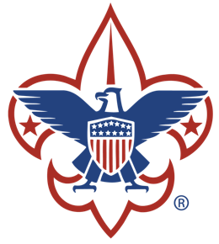

Troop 447 Code of Conduct

Overview:
The purpose of this document is to establish a code of conduct within the troop that all members, adults and boys, will be held to. The guidelines have been established under the guidance of the troop committee and are intended to be a starting point for discussions on matters of behavior, discipline and personal safety. They state what is expected of the boys and what discipline might be implemented if the code of conduct is not followed. This guide can be updated, adapted, or changed at any time with the approval of the troop committee.
The use of the word "adult" refers to members of Troop 447 over the age of 18. The use of the word "parent(s)" refers to the adult legal guardian(s) of the boy members of the Troop. This term is in no way intended to exclude anyone; it is merely a handy way to refer to the adults in our scout's lives. The use of the word Scout, or boy refers to the boy members of the troop.
Behavior Guidelines:
The Boy Scouts of America is a values-based youth development organization that helps young people learn positive attributes of character, citizenship, and personal fitness. The BSA has the expectation that all participants in the Scouting program will relate to each other in accord with the principles embodied in the Scout Oath and Law:
On my honor I will do my best to do my duty to God and my country and to obey the scout law at all times; to help other people at all times and to keep myself physically strong, mentally awake and morally straight.
A Scout is Trustworthy, loyal, helpful, friendly, courteous, kind, obedient, cheerful, thrifty, brave, clean, and reverent.
Boys and adults are expected to show respect for each other and for individual differences. Older boys are further expected to help the younger boys advance by teaching them life skills and the skills necessary to advance to the next rank in Boy Scouting. At all times, troop members are expected to make the Boy Scout Oath and Scout Law their CODE OF CONDUCT.
In keeping with the standards of scouting, the following behaviors will not be tolerated:
- Failure to follow the Patrol Method
- Failure to follow reasonable directives from scout leaders (including patrol leaders, senior patrol leaders, etc.)
- Unnecessary or inappropriate physical roughness. Unless participating in a contact game, all Scouts are expected to abide by a "hands-off" policy with their fellow Scouts, adult leaders and property.
- Foul language that offends, degrades or is negative and derogatory banter.
- Behavior that displays disrespect for other person’s, personal property or the environment.
- Harassment in any form - verbal, physical, sexual or racial. This includes intimidating conduct (ridiculing/ teasing) and fighting.
- Intentional property damage or stealing.
- Any act which may endanger the health or safety of oneself or others or the threat of committing such acts.

Discipline Policy:
There are times when it is necessary to discipline a Scout for abusing the Code of Conduct. Fortunately, serious problems rarely arise due to the good character of our Scouts. When there are problems, cooperation among Scouts, the Scoutmaster and parents often turn problems into opportunities for growth and character development. It is the responsibility of the Scoutmaster, or the adult leader in charge, to supervise the discipline of the Scout.
How Scouts are disciplined, by whom, when, and where are important issues that must be clearly established and communicated to all Scouts, parents, and leaders. Scouts have a “right” to know what the consequences are if they break the rules. Scouts who follow the Scout Oath and Law have a “right” to expect a Troop to discipline Scouts who disrupt Troop programs and activities or threaten the safety or well being of other Troop members.
The Scoutmaster or adult leader will decide what course of action is necessary given the situation. Discipline sessions are to be conducted off to the side, but in full view of Scouts or adults, by at least 2 adults and never in private one on one (Youth Protection Guidelines). Adults always have the right and responsibility to immediately step into any situation they consider unsafe. These situations include, but are not limited to: fighting, hazing, foul language, bullying, sexual misconduct, or inappropriate behavior.
Disciplinary Action Plan:
The principle first line of discipline is to clearly communicate Patrol and Troop expectations in reference to Scout behavior. When discipline problems occur that need more than a friendly reminder from a Scout’s peers or supervising adults, the following steps will be taken:
- Scoutmaster/Adult Leader Conference. The Scoutmaster or adult leader will take the boy(s) aside and ask the boy(s) to stop the inappropriate behavior. The Scout(s) will be issued a warning by two adult leaders in the form of a counseling session. The session will be in full view and within hearing distance of additional adult leaders. The Scout(s) will be required to issue a verbal apology.
- Parent Contact. The Scoutmaster will initiate contact with the parent to discuss the inappropriate behavior. This is a two-way conversation as both parties strive to find a way that will encourage the Scout(s) to meet the behavior expectations. A verbal and/or written apology will be required.
- Dismissal from the Event. If a serious situation occurs at any scouting event (a Scout who is disruptive or a danger to himself or others) the adult leader may contact the parent(s) and ask them to remove the Scout from the premises. The Scout(s) will be placed on probation and prohibited from attending scout functions for a determined amount of time. A written apology will be required.
- Parent Attendance. If after the initial Parent Contact, the Scoutmaster Staff believes that inappropriate behavior is likely to continue, the Parent will be required to attend events with their Scout until such time as the Scoutmaster corp. believes it is no longer necessary.
- Troop Committee. If a problem situation persists, or if it is serious enough, the parent(s) and the Troop Committee (minus the Scoutmaster) will meet to discuss the conditions under which the Scout may remain a member of the Troop or discuss the Scout’s dismissal from Troop 447

These guidelines and list of disciplinary measures will become effective on August and will remain in effect until modified or revoked by the Troop 447 Committee.

All scouts and their parents/legal guardians are expected to abide by the Code of Conduct. A Code of Conduct Agreement is being distributed with this memorandum. All scouts and their parents/legal guardians are expected to review and sign the Code of Conduct Agreement. Scouts may not participate in Troop 1 events until the Code of Conduct Agreement is signed.

Boy Scouts of America

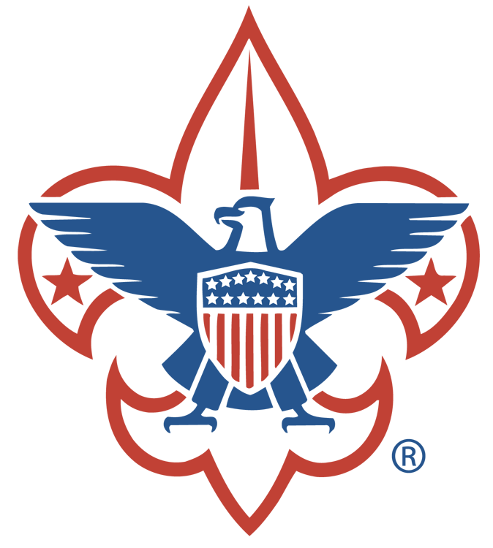

Troop 447

Code of Conduct and Discipline Agreement
I have read the Troop 447 Code of Conduct and understand what is expected of me. I will abide by the Scout Oath, the Scout Law and the Outdoor Code. I will show respect to others, be friendly to my fellow Scouts, and show “Scout Spirit”.
In choosing to participate in Troop 447 meetings and activities, I hereby indicate my agreement and commitment to observe Troop 447’s Code of Conduct Policy.

__________________________________ __________________________________
Scout’s Signature Date

I consent to my son’s participation in Troop 447’s meetings and activities. I hereby indicate my understanding and agreement with Troop 447’s Code of Conduct and Discipline Policy, and I agree to support my son’s commitment to the Troop’s Code of Conduct Policy.

___________________________________ ___________________________
Parent or Guardian Signature Date

