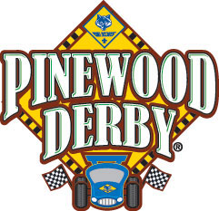
Foothills District - 2017
Pinewood Derby
ALL VEHICLES MUST BE REGISTERED
AND PASS INSPECTION BEFORE RACES BEGIN

SCOUTS HONOR!
Inspection Points:
- The car weight cannot exceed 5.0 ounces. Official race scale will be considered the final determining factor
- The car cannot exceed the following dimensions: length (7 inches), height (5 inches), and width (2 ¾ inches)
- The car must have 1 ¾ inches clearance between the wheels
- The car must have 3/8 inches clearance underneath the body(more is recommended)
- The wood provided in the kit MUST be used. The car may be shaped in any way desired.
- BSA wheels must be used. Other than removing wheel seams, wheels cannot be altered in any other way. (buffing or polishing is allowed)
- BSA axles must be used and can be polished or lubricated.
- Wheels bearings, washers, and bushings are prohibited.
- The car cannot ride on any type of springs.
- The car must be free-wheeling and have no starting devices
- No loose material such as lead shot can be used.
- You must use the precut axle slots. Approximately 4 3/8” between axles.
Additional Rules:
- The car body must have no moving parts
- Construction on car must have begun AFTER last year’s race
- One car per person per category
- Only dry lubricants allowed on wheels and cannot foul the track
- Only one lubricant application allowed before race
- If, during a race, a car leaves the track and does not interfere with its opponent, It shall be considered to have ended its heat. The car may be inspected and repaired if needed, but no lubricant may be applied.

