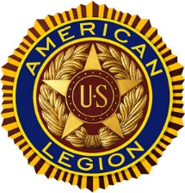
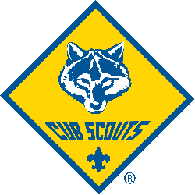
Welcome to Cub Scout Pack 510
Barker’s Mill Elementary School
Chartered by
American Legion CSM Gary W. Crisp Post 289

You Are Not Alone!
Your den is in a pack that belongs to an organization chartered by the Boy Scouts
of America (BSA) to operate a Scouting unit (American Legion CSM Gary W. Crisp Post 289 is your Pack’s chartered organization) The chartered organization approves leadership, helps secure a meeting place, and makes sure that the pack works within the guidelines and policies of their organization as well as those of the BSA.

Many volunteers and BSA professionals are interested in the success of your pack.

A special volunteer assigned to help your pack is called a commissioner. The
commissioner helps the pack provide a successful and high-quality program. The
commissioner is also the communication link between your pack and the local council.

All leaders need training to be effective. The BSA provides both online and
instructor-led training for adult volunteers in how to be a successful leader. Your District is Cogioba and we are in Middle Tennessee Council.

My son is in Pack 510, which meets at _________________________________ (location)
at __________ (time) on _______________________________ (day and week of month).
He is in Den _________________, which meets at _______________________ (location)
at __________ (time) on ________________________ (day of week).
Our pack’s-chartered organization is American Legion CSM Gary W. Crisp Post 289.
Our local council name is Middle Tennessee Council.
Phone No. __________________ Website: http://pack510clarksville.ScoutLander.com
Our Pack Facebook Page: Clarksville Pack 510
Our Leaders Name Phone No. Email
Den leader _____________________________ ____________ ____________________
Committee Chair ________________________ ____________ ____________________
Cubmaster __________________

